Bookchoosing cards for the Refugee Reading Project

Each students gets 6 postcard-size book-choosing cards. In order to print these cards in the right format follow these instructions:

Print pages 2 to 15 .

Print 4 pages on 1 (A4)

Print double sided.

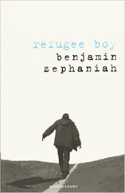

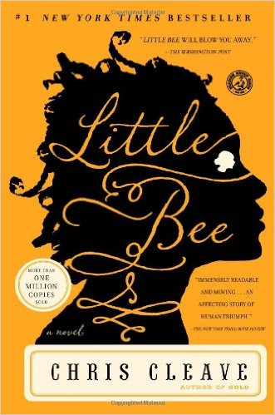

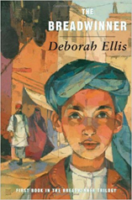

Finding out about the book:

Setting: Where and when…
Main character and his/her problem
Dangers and obstacles
Wishes and hopes
Interest factor

Finding out about the book:

Setting: Where and when…
Main character and his/her problem
Dangers and obstacles
Wishes and hopes
Interest factor

Finding out about the book:

Setting: Where and when…
Main character and his/her problem
Dangers and obstacles
Wishes and hopes
Interest factor

Finding out about the book:

Setting: Where and when…
Main character and his/her problem
Dangers and obstacles
Wishes and hopes
Interest factor

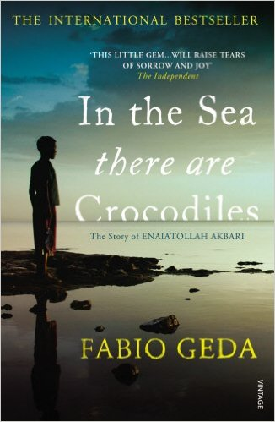

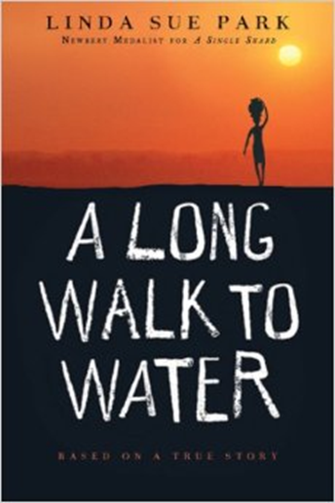

Finding out about the book:

Setting: Where and when…
Main character and his/her problem
Dangers and obstacles
Wishes and hopes
Interest factor

Finding out about the book:

Setting: Where and when…
Main character and his/her problem
Dangers and obstacles
Wishes and hopes
Interest factor

