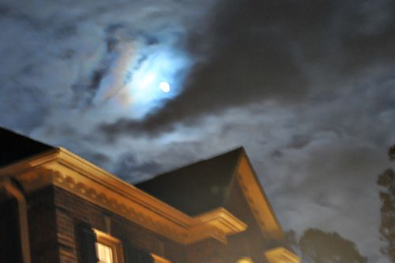
It was midnight. The moon was shining and a cold storm was howling outside. The cat was sleeping in front of the fire and dreaming of summer and mice in the garden. Mrs. Oldenburry was sitting in her rocking-chair knitting a sweater for her son. Tommy was sleeping in his crib on the other side of the room while Mr. Oldenburry was reading the paper and smoking a pipe.
SUDDENLY there was a knock on the door. It was a ghost! The cat jumped up and growled in terror. Mrs. Oldenburry fell off her chair and fainted and Mr. Oldenburry grabbed his chair and threw it at the ghost.
Only little Tommy seemed undisturbed. He was still sleeping peacefully in his crib.

It was midnight. The moon was shining and a cold storm was howling outside. The cat was sleeping in front of the fire and dreaming of summer and mice in the garden. Mrs. Oldenburry was sitting in her rocking-chair knitting a sweater for her son. Tommy was sleeping in his crib on the other side of the room while Mr. Oldenburry was reading the paper and smoking a pipe.
SUDDENLY there was a knock on the door. It was a ghost! The cat jumped up and growled in terror. Mrs. Oldenburry fell off her chair and fainted and Mr. Oldenburry grabbed his chair and threw it at the ghost.
Only little Tommy seemed undisturbed. He was still sleeping peacefully in his crib.
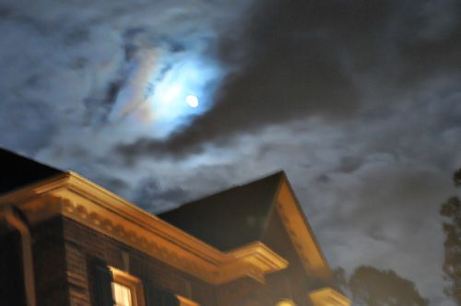
Era mezzanotte. Un forte vento spingeva le nuvole che nascondevano la luna.
Davanti al camino in salotto dormiva il gatto e sognava di un giardino pieno di topi.
Signora Leoni era seduta in una comoda poltrona e finiva il golfino per il suo piccolo. Antonio dormiva beato nella sua culla.
Singore Leoni leggeva il giornale e fumava la pipa.

All'improvviso hanno bussato alla porta: era uno spirito!
Il gatto si è spaventato ed è schizzato via. Signora Leoni è caduta dalla poltrona ed è svenuta. Signore Leoni ha preso la sua sedia e l'ha tirata addosso allo spirito.
Solo il piccolo Antonio non sembrava disturbato. Continuava a dormire tranquillo nella sua culla.

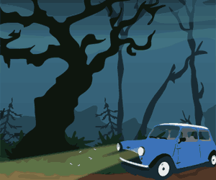
Il faisait nuit noire quand un vent terrible c'est levé!
Les arbres dénudés par l'hiver, semblaient frileux sous la lune.
Je me dirigeais vers la colline, penchée en avant, et bousculée par le vent, je savais qu'il fallait l'atteindre au plus vite, je savais la tempête proche, dangereuse!
La maison au loin, semblait vide, je devais absolument arriver avant que la folie de la nature, se mette en branle.
Soudain, un fracas terrible me fit me retourner, un arbre déraciné venait d'écraser ma voiture, plus question de retour en arrière.
Soudain, je le vit, sifflotant sur la colline, ces petits pains au chocolat à la main, il m'avait attendu, attendu, et je suis venue !
http://nina1955.blog.fr/2011/01/13/il-faisait-nuit-noire-quand-un-vent-terrible-c-est-10361341/

fröstelnd, kalt, frierend
durchgebeutelt, durchgeschüttelt
se mettre en branle: loslegen,
fracas: Krach

